Machine Learning-Driven Weather Prediction and Data Analytics for Mitigating Disruptions
In International Cricket Events in Pakistan
Syeda Faiza Nasim¹, Umm-e-Kulsoom², Syeda Alishba Fatima³, Salka Naushad⁴
¹Ph.D Candidate at NED University of Engineering and Technology, Pakistan
²Lecturer of Computer Sciences at Iqra University, Pakistan
³MS-CSIT Student at NED University of Engineering and Technology, Pakistan
⁴Lecturer of Mathematics at Dow University of Health Sciences, Pakistan
Corresponding author: Syeda Faiza Nasim, sfnasim@cloud.neduet.edu.pk

Abstract:

The forthcoming ICC Champions Trophy in 2025, scheduled to take place in Pakistan, presents prominent logistical difficulties due to climate variability. Precise weather predictions are crucial for avoiding interruptions and confirming smooth event organization, particularly for outdoor games. This research paper highlights the implementation of machine learning techniques and applying data analytics to forecast weather conditions, concentrating mainly on precipitation, in three key Pakistani cities: Karachi, Lahore and Rawalpindi. The dataset is fetched from free weather API from Open-Meteo, integrated real-time weather information with historical climatic conditions for past years. Python-based libraries are used to predict weather conditions in upcoming series. These forecasts are subsequently shown via interactive dashboards using Power BI, offering key stakeholders’ practical insight through dashboards into weather patterns relevant to the event schedule for the matches.
Keywords: Climatic Variability in Pakistan, Data Analytics, Machine Learning, Open-Meteo Stat, Rain Prediction

INTRODUCTION
Hosting the ICC Champions Trophy in Pakistan in 2025 requires thorough consideration of local weather patterns, which are ever more impacted by climatic variation. Accurate weather forecasts are critical for outdoor events to prevent terminations caused by rain or extreme heat. In the sports domain, AI evaluates climate suitability for major events like the Olympics, fostering strategies resilient to climate variation. Additionally, machine learning models can analyze vast amounts of historic and current climate data to foresee weather interruptions such as rain or temperature fluctuations, enabling better planning. Incorporating weather data into sports event management allows organizers to devise possibilities strategies and improve operational efficiency. Visualization tools like Power BI facilitate quick interpretation of data through user-friendly dashboards, helping stakeholders make knowledgeable decisions to confirm the smooth conduct of the tournament amid changing climate conditions.

LITERATURE REVIEW
AI algorithms and data analytics are changing various industries by enabling precise predictions and better decision-making. Below here in Table 1 numerous papers are compared after going through multiple research papers on climatic variations and their impact on games and stakeholders’ decision making. Key findings emphasize that these approaches help in selecting optimal event locations to reduce weather-induced interruptions and provide predictions that empower organizers to plan efficiently, thereby certifying improved practices for participants and audiences.

Table 1: Key Findings

Paper ID | Key Findings | Limitations
[1-5] | This research developed an application that forecasts the optimal locations for outdoor sporting events, particularly cricket matches, based on meteorological data to minimize rain delays. A variety of machine learning techniques were used, with the Random Forest model producing the final predictions. The intention is to help event planners choose the ideal venue to minimize financial losses and spectator frustration caused by weather-related cancellations. | Further study was necessary to evaluate and improve the methods, as this was the first attempt to predict rain interruptions during cricket matches.

[6-10] | A clear shift in the pattern of game play, including a notable decrease in running at high level of intensity, has been shown in scientific football study involving control & heated matches conducted with standardized setups1. Retrospective evaluations of the 2014 FIFA World Cup2 also demonstrate this shift. | Rising ambient temperatures due to global warming are expected to have an impact on the planning & performance of future football tournaments. Even while running at a high intensity is reduced in hot conditions, peak sprinting speeds and overall fatigue are unaffected.
[11-  14] | Cricket is an effective medium for conveying to worldwide audiences the dangers & truths of climate change. A new agreement concerning the cricket's role in reducing the adverse effects of the climate change is being worked out by stakeholders in sport, politics, media, and the environment. The urgency of these activities stems from cricket's specific sensitivity to intense heat, rain, drought, and flooding, both in the present and the future. | No statistical conclusions or algorithms were used by the writers.
[15-  19] | The study's purpose was to provide climatic information to a wide range of stakeholders so that they could understand the importance of climate and environmental change. Multiple machine learning models were utilized to forecast rainfall, and this hybrid model achieved a maximum accuracy of 81.2%, illustrating the effectiveness of ensemble techniques in rainfall forecasting. It suggested that the proposed stacking ensemble model is a flexible and acceptable framework for predicting rainfall in other regions as well. | Predicting rainfall remains difficult due to unpredictable weather patterns; the stacking ensemble model, while boosting accuracy, still has scope for further improvement, with a maximum accuracy of 81.2%.
[20- 23] | The next Olympic Games & FIFA World Cups from 2022 to 2032 may face heat and air quality concerns, which may cause the competitions to be delayed. Long-term environmental issues could affect the legacy of the events. | The most pressing issues for the mega events from 2022 to 2032 include scorching temperatures that are not appropriate for competition & poor air quality, but there can be more serious environmental concerns for the events' long-term effects. Event planners need to think about building infrastructure, legacies, and events that are climate resilient and able to withstand environmental hazards in the future.

METHODOLOGY
We utilise Open-Meteo, an open-source weather API, to acquire climate data; no API key is needed. Using a potent blend of global (11 km) & mesoscale (1 km) weather models from reputable national forecasting agencies, Open-Meteo produces extensive forecasts with exceptional accuracy, with 10 km resolution hourly weather data spanning more than 80 years accessible. It also provides free use to its APIs for non-commercial purposes, which makes it easy for us to investigate & incorporate meteorological data into our projects. Our focus is on three cities: Karachi, Lahore, and Rawalpindi, where eight teams are set to compete in the 2025 Champions Trophy. Initially, historical data from January 2019 to August 2024 is retrieved to forecast the amount of rain in different cities based on fifteen match days.
Our research paper is based on six research questions, as illustrated below in Figure 1.

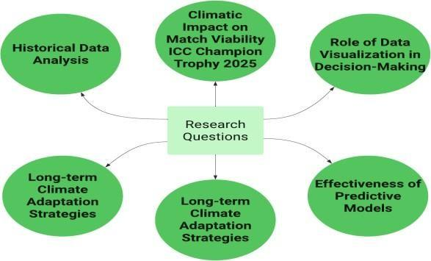
Figure 1: Proposed Research Question
Figures 2- 4 depict climate information for Karachi, Lahore, and Rawalpindi. This dataset is fetched from Open MetoStat(Free Weather API). We initially cleaned the dataset to ensure correctness and dependability after gathering the data. The data cleaning process includes handling missing numbers, eliminating duplicates, correcting discrepancies, and standardizing data formats. This preliminary processing ensures that the data is ready for inspection and illustration, which are critical components of subsequent analysis
.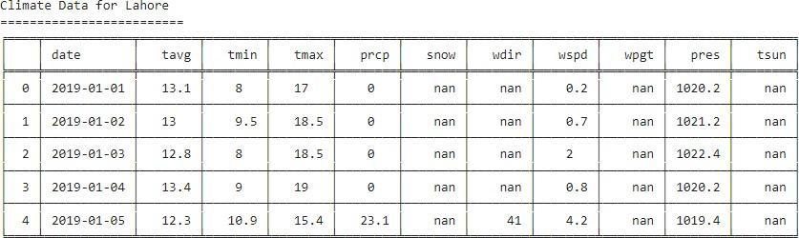

Figure 2: Climate Data for Lahore

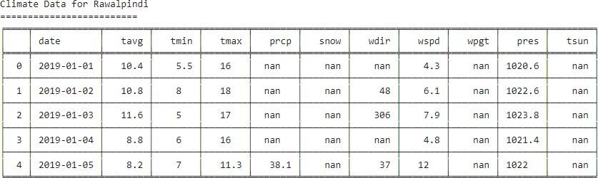
Figure 3: Climate Data for Rawalpindi
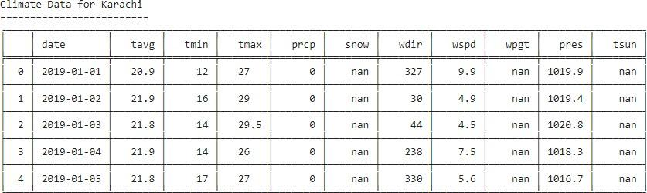
Figure 4: Climate Data for Karachi

By applying the linear interpolation technique on all three cities' data, namely, we fill in the missing values for the columns that were to be cleaned. The sample code that follows iterates through the list of columns (such as temperature, humidity, etc.) that require cleaning and uses the interpolation method to fill in any gaps in the data is explained below:
for column in columns_to_clean:
if column in karachi_df.columns: karachi_df[column] = karachi_df[column].interpolate(method='linear')

We applied machine learning algorithms to predict the weather, including the probability of rain. More specifically, we trained on weather data features includes average temperature (tavg), minimum temperature (tmin), maximum temperature (tmax), and precipitation (prcp) using the Linear Regression model from the sklearn.linear_model package. To prepare the data, train the linear regression models, and forecast future dates, the function predict_city_weather was created. The script creates forecasts and calculates the probability of rain based on anticipated precipitation after training the models for each meteorological feature, as shown below in Figure 5.

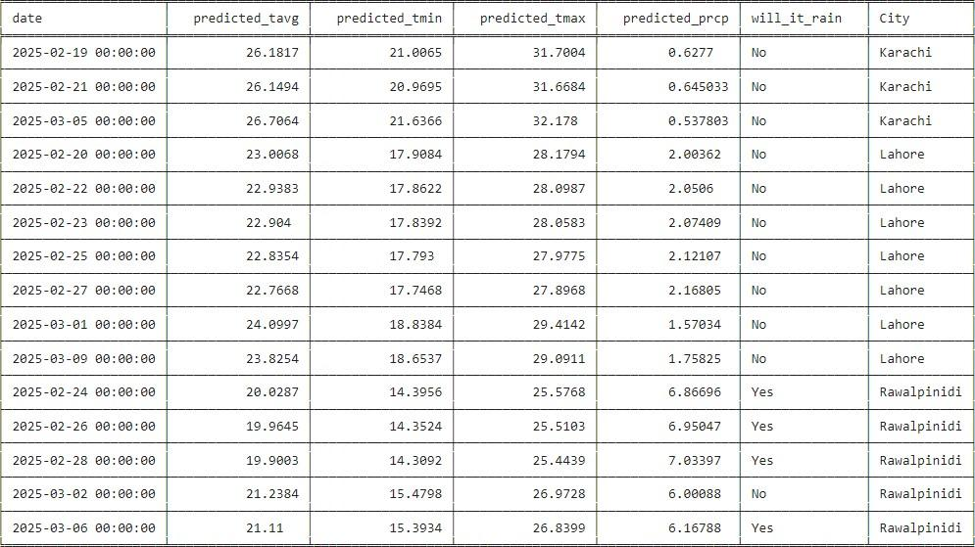

Figure 5: Predicted Climatic Values for ICC Champion Trophy (Rawalpindi, Lahore & Karachi)
In our proposed research, we have utilized Power BI for data visualization in addition to Python and OpenMetoStat, since it is an essential part of data analysis and provides clear and interesting insight into the data. A popular tool for data analysis, Microsoft Power BI shines at offering a variety of dynamic methods to visualize data. A variety of columns, including precipitation (prcp), wind direction (wdir), wind speed (wspd), pressure (pres), rain, and city, were used to illustrate the results as shown in Figure 6 below.

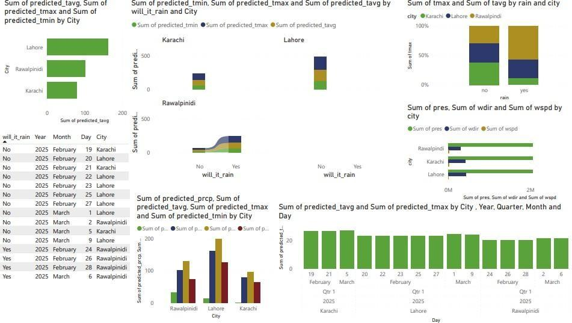
Figure 6: Visualization using Power BI on ICC Champions Trophy 2025(Pakistan)

RESULTS
Proper interpretation of the results highlights the significant role that AI algorithms and data analytics play in improving decision-making and predicting climate-related impacts across various sectors. Power BI dashboard includes historical data from Open Meteostat as well as predicted numbers for the ICC Champions Trophy 2025. This dashboard, presented in Figures 7, 8, & 9 respectively, provides a thorough perspective of the data through a series of interrelated visual graphs for Rawalpindi, Lahore, and Karachi. For a more comprehensive understanding of weather patterns and forecasts, the concept of Slicer is used, which enables to presentation and analysis of the data between Sum of predicted_tavg, Sum of predicted_tmax, and Sum of predicted_tmin by city for all three cities, including Rawalpindi, Lahore, and Karachi.

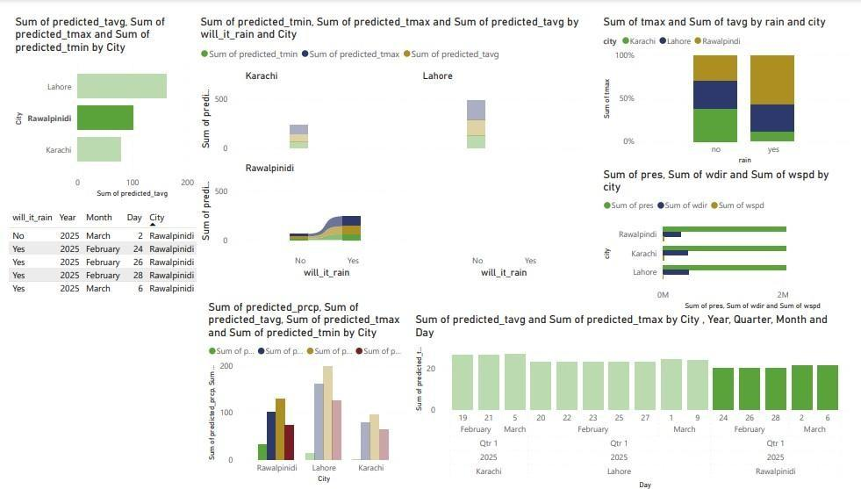
Figure 7: Dashboard for Rawalpindi (2025)
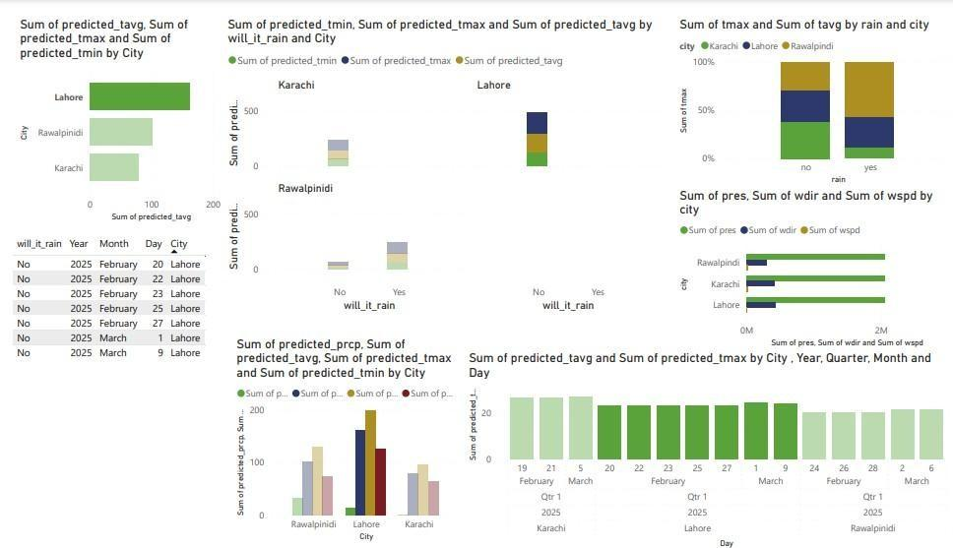Figure 8: Dashboard for Lahore (2025)
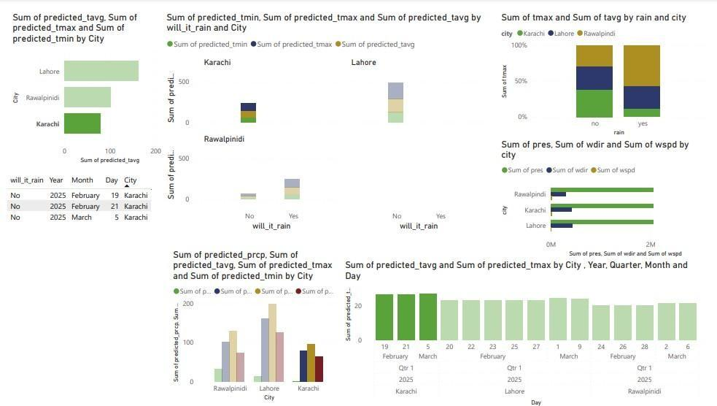

Figure 9: Dashboard for Karachi (2025)
Additionally, the below Figures 10 & 11 dashboard gives insights into how the temperature, rain, and city are correlated and in which Year, Quarter, and month rain is expected, focusing on ICC Champions Trophy 2025 schedule.
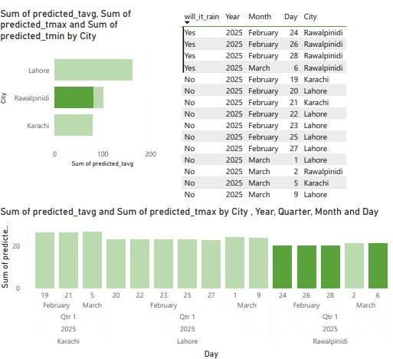

Figure 10: Rawalpindi Rain Prediction Visualization (2025)

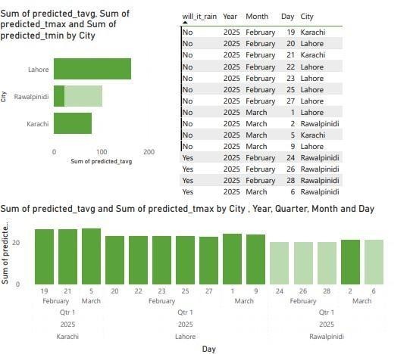
Figure 11: Weather Prediction Visualization during ICC Champions Trophy (2025)

CONCLUSION
This study highlights the important relationship between climate science and sports, including cricket, by using cutting-edge machine learning algorithms to anticipate rain delays and enhance event scheduling. Our analysis, based on historical data and shown using dynamic tools such as Power BI, provides stakeholders with actionable insights about meteorological patterns in important cities— Karachi, Lahore, and Rawalpindi—during the ICC Champions Trophy 2025, as illustrated below in Figure 12. Our research also emphasizes how critical it is for the sports industry to confront the threats that climate change poses, encouraging cooperation between the political, sports, and environmental domains. By using cricket as a vehicle for climate advocacy, we can spread knowledge and encourage group action in the direction of a sustainable future for the game and the aircraft.
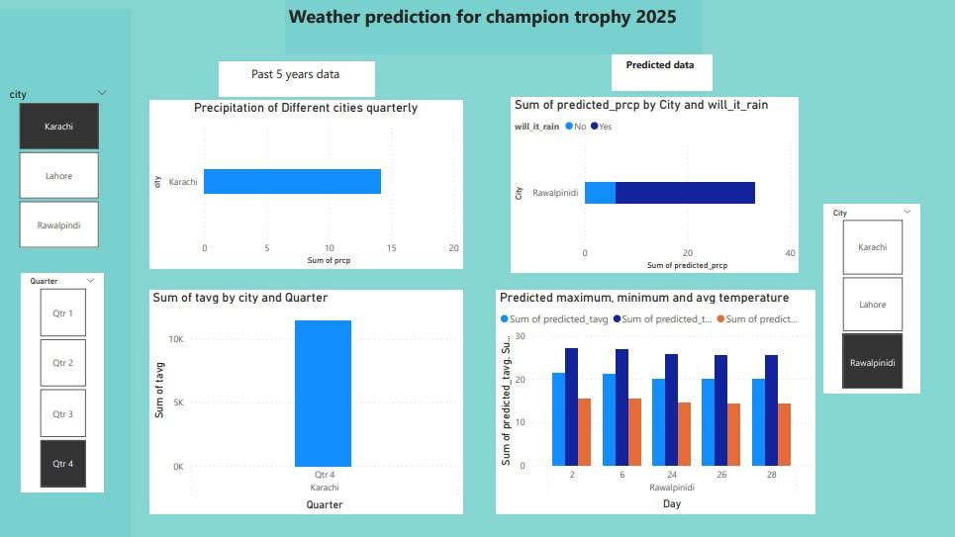
Figure 12: Weather Prediction (Rain) For ICC Champion Trophy 2025

REFERENCES
- Nasim, S. F., & Haider, N. G. (2024). Improving Pakistan weather forecasting accuracy with machine learning: A data-driven approach. In 2024 Global Conference on Wireless and Optical Technologies (GCWOT) (pp. 1–6). IEEE. https://doi.org/10.1109/GCWOT63882.2024.10805743
- T. Bhalerao, S. Vijayalakshmi, and J. G. Gokulakrishnan, A Comparative Analysis on Machine Learning Algorithm for Score Prediction and Proposal of Enhanced Naïve Bayes. 2022, pp. 618-621.
- A. Naik, A. Deorankar, and P. Ambhore, Rainfall Prediction based on Deep Neural Network: A Review. 2020, pp. 98-101.
- A. Balasundaram, S. Ashokkumar, D. Jayashree, and S. Magesh Kumar, "Data mining-based Classification of Players in Game of Cricket," 2020 International Conference on Smart Electronics and Communication (ICOSEC), pp. 271-275, 2020.
- N. Kailasanathan, S. Nazz, K. Madhuvanthi, S. Karthikeyan, and M. Medarametla, Predicting the weather for
Uninterrupted Cricket matches and Outdoor Sports events. 2019, pp. 451-458.
- S. Wang et al., "Warming climate is helping human beings run faster, jump higher and throw farther through less dense air," npj Climate and Atmospheric Science, 2024.
- V. Gouttebarge, R. Duffield, S. den Hollander, and R. Maughan, "Protective guidelines and mitigation strategies for hot conditions in professional football: starting 11 Hot Tips for consideration," BMJ Open Sport & Exercise Medicine, vol. 9, p. e001608, 07/21 2023, doi: 10.1136/bmjsem-2023-001608.
- M. V. de Sousa et al., "Nutritional optimization for female elite football players-topical review," (in eng), Scand J Med Sci Sports, vol. 32 Suppl 1, pp. 81-104, Apr 2022, doi: 10.1111/sms.14102.
- W. J. Ross and M. Orr, "Predicting climate impacts to the Olympic Games and FIFA Men’s World Cups from 2022 to 2032," Sport in Society, vol. 25, no. 4, pp. 867-888, 2022/03/21 2022, doi: 10.1080/17430437.2021.1984426.
- L. Nybo, A. Flouris, S. Racinais, and M. Mohr, "Football facing a future with global warming: perspectives for players health and performance," British Journal of Sports Medicine, vol. 55, pp. bjsports-2020, 07/01 2020, doi: 10.1136/bjsports-2020-102193.
- B. Hutchins, S. Troon, T. Miller, and L. Lester, "Envisioning a green modernity? The future of cricket in an age of climate crisis," Sport in Society, vol. 26, pp. 1-15, 03/23 2023, doi: 10.1080/17430437.2023.2190516.
- D. Malcolm and S. Naha, "Cricket at the beginning of the long twenty-first century," Sport in Society, vol. 24, pp. 1-7, 06/07 2021, doi: 10.1080/17430437.2021.1932307.
- S. Wagg, "Towards a safer past: thoughts on the invocation of English cricket’s soul," Sport in Society, vol. 24, no. 8, pp. 1455-1471, 2021/07/24 2021, doi: 10.1080/17430437.2020.1815709.
- G. Dingle and B. Stewart, "Playing the climate game: climate change impacts, resilience and adaptation in the climate-dependent sport sector," Managing Sport and Leisure, vol. 23, pp. 1-22, 09/30 2018, doi: 10.1080/23750472.2018.1527715.
- H. Bommala, G. Kumar, B. Babu, M. Sivajyothi, M. Kumar, and S. Basha, A Review on Ensemble Model-Based
Rainfall Prediction Techniques. 2024, pp. 1474-1478.
- P. Jaiswal et al., A Stacking Ensemble Learning Model for Rainfall Prediction based on Indian Climate. 2023, pp. 1-6.
- S. Sunori, M. Manu, A. Mittal, P. Juneja, and G. Jethi, Climatic Categorization Using Artificial Neural Networks. 2024, pp. 161-166.
- P. Purushotham, A. Kiran, K. Anuradha, T. B. Reddy, S. Vinay, and N. S. B. Manne, "Changing Tides with AI- Powered Climate Change Analysis," in 2024 International Conference on Science Technology Engineering and Management (ICSTEM), 26-27 April 2024 2024, pp. 1-7, doi: 10.1109/ICSTEM61137.2024.10561131.
- S. Manoj and C. Valliyammai, "Analysis of shift in Indian monsoon and prediction of accumulated cyclone energy in Indian subcontinent using deep learning," Automatika, vol. 64, pp. 1116-1127, 08/26 2023, doi: 10.1080/00051144.2023.2250640.
- L. Mougin et al., "Environmental challenges facing athletes, stakeholders and spectators at Paris 2024 Olympic and Paralympic Games: an evidence-based review of mitigation strategies and recommendations," (in eng), Br J Sports Med, vol. 58, no. 15, pp. 870-881, Jul 25 2024, doi: 10.1136/bjsports-2024-108281.
- B. P. McCullough, "Advancing sport ecology research on sport and the natural environment," Sport Management
Review, vol. 26, no. 5, pp. 813-833, 2023/10/20 2023, doi: 10.1080/14413523.2023.2260078.
- D. Scott, N. L. B. Knowles, S. Ma, M. Rutty, and R. Steiger, "Climate change and the future of the Olympic Winter Games: athlete and coach perspectives," Current Issues in Tourism, vol. 26, no. 3, pp. 480-495, 2023/02/01 2023, doi: 10.1080/13683500.2021.2023480.
- M. Orr and W. J. Ross, "Assessing Climate Suitability of Three Cities for the 2027 Women’s World Cup," Case Studies in Sport Management, 2022.
- Nasim, S. F., Umm-e-Kulsoom, & Fatima, S. A. (2025). Sustainable agriculture systems transformed: The role of drones in enhancing precision, safety and efficiency. In V. P. Bagnato et al. (Eds.), Sustainable approaches to environmental design, materials science, and engineering technologies (Vol. 1, pp. xx–xx). Springer. https://doi.org/10.1007/978-3-031-76025-9_36
- Nasim, S. F., Fatima, S. A., Ahmed, S., Naushad, S., & Umm-e-Kulsoom. (2025). Evapotranspiration model and crop water requirements: Implications for agricultural sustainability. In V. P. Bagnato et al. (Eds.), Sustainable approaches to environmental design, materials science, and engineering technologies (Vol. 1, pp. xx–xx). Springer. https://doi.org/10.1007/978-3-031-76025-9_35
- Enhancing agriculture prediction through AI and parallel distributed computing: A comprehensive study on the impact of weather. (2023). International Journal of Emerging Engineering and Technology, 2(2), 21–28. https://doi.org/10.57041/7d1afq32
- Feroze, S. A., & Nasim, S. F. (2022). Genetic testing of Huntington’s disease by facial examination of a mankind using AI programs. In 2022 3rd International Conference on Innovations in Computer Science & Software Engineering (ICONICS) (pp. 1–9). IEEE. https://doi.org/10.1109/ICONICS56716.2022.10100480
- Nasim, S. F., Qaiser, A., Abrar, N., & Kulsoom, U. (2023). Implementation of AI in traffic management: Need, current techniques and challenges. Pakistan Journal of Scientific
Research,3(1),20–25https://doi.org/10.57041/vol3iss1pp20-25

